Technology Transfer - Proof of Concept Proposals
[Name Project]
[Year]
[TechReceiver]
INDEX
PROPOSAL FOR TECHNOLOGY TRANSFER – PROOF OF CONCEPT 2020 3
1. COVER LETTER 3
2. PROPOSAL 7
2.1 SPACE HERITAGE 8
2.2 NEW APPLICATION OF THE SPACE HERITAGE 8
2.3 PROOF OF CONCEPT 9
2.4 DELIVERABLES AND REPORTS 12

PROPOSAL FOR TECHNOLOGY TRANSFER – PROOF OF CONCEPT 2020

COVER LETTER
SUBJECT: [insert subject]
Your REF: [insert reference]
Dear Madam, dear Sir,
In response to the Open Call (the Call) issued by VERHAERT, we are pleased to submit our proposal:
The Tenderer (potential Contractor) is:
.... (full name of company or institute)
.... (address of its seat)
Fax number: .......
Telephone: ........
Nationality (according to ESA Convention’s criteria): ........
VAT Number: …….
Please find attached hereto the following documents:
- Proposal of technology transfer – Proof of Concept
- Draft contract
- Your attention is drawn to the following:
  - The present call is open to space and non-space companies (including SMEs), academic and research organizations from ESA Member States and Associate States.
  - The subject of this call is exclusively for the Technology Transfer Proof of Concepts activities. The technology transfer refers to use the / exploitation of a space heritage technology into a new ground application domain.
The space heritage technology can be hardware, software, know-how, processes, methodologies or systems developed or adapted for space applications. The mere use of space data for a ground applications is not considered a technology transfer.
The tenderer is requested to demonstrate the technical and market feasibility before the onset of the Proof of Concept. The findings shall be summarized in the PoC proposal, according to the PoC proposal template.
The Proof of Concept consists of both a desk study (development of a business model and development plan) as well as the building and testing of a prototype (breadboard for HW, Alpha version of a SW) against most critical technical requirements. More specifically, the work (and report) shall address the following elements:
- Business Plan (Business Canvas Model)
- Verification Tests (Elaborate the technical requirements, procedures and implement a test plan)
- Technical Design and Demonstration Plan (System Design/architecture and elaborate a demonstration plan towards maturity, including your budget plan to achieve your objectives)
- This proposal is valid for [insert number of months] from the date of submission [with a minimum period of 6 months]; The PoC must be carried out within 6 months from the kick-off-meeting.
- The Application is compliant with the Requirements set out in the Call;
- The draft Contract has been read, understood and accepted;
- A statement of compliance with the price stated in the Call;
- The proposal shall be send to “demonstrators@spacesolutions.be” before the deadline mentioned on the website https://spacesolutions.be/technology-transfer/demonstrator/
- VERHAERT is allowed to include the electronic version of the Public Summary of the work carried out in its Proof of Concept database with public access.
  - The proposal shall be evaluated against the following criteria and weighting factors
    - Suitability of space heritage technology (space connection, relevance in relation to problem, maturity, feasibility) for the transfer. 20%
    - Market opportunity (validated problem and value proposition, product / market fit, market potential). 30%
    - Quality of the proposal (clarity, completeness); Suitability of implementation approach; Adequacy of involved resources (personnel, facilities, end-user representative) for the execution of the work. 40%
    - Quality of the management plan and financial proposal; Compliance with the administrative tender conditions of the announcement of opportunity and acceptance of the draft contract. 10%
Any queries relevant to the proposal are to be addressed to:
[insert name]
Address:
Phone:
Fax: Email:

Contact information of the person(s) who will be in charge of Technical matters:
[insert name]
Address:
Phone:
Fax: Email:
Contact information of the person(s) who will be in charge of day-to-day management:
[insert name]
Address:
Phone:
Fax: Email:

Contact information of the person(s) who will be in charge of signing the contract:
[insert name]
Address:
Phone:
Fax: Email: Signature & Dat

PROPOSAL

Descriptive Title: [Describe the technical-core aim for your application]
Abstract [Key elements on the technology and its new application – Max 5 lines including keywords]

Technology Domain of the space heritage: [Which Technology Domain covers your TD]

TD # | Technical Domain description | Applicable TD
1 | On-Board Data Systems | ☐
2 | Space System Software | ☐
3 | Spacecraft Electrical Power | ☐
4 | Space Environments & Effects | ☐
5 | Space System Control | ☐
6 | RF Payload and Systems | ☐
7 | Electromagnetic Technologies & Techniques | ☐
8 | System Design & Verification | ☐
9 | Mission Operation & Ground Data systems | ☐
10 | Flight Dynamics & GNSS | ☐
11 | Space Debris | ☐
12 | Ground Station System & Networks | ☐
13 | Automation, Telepresence & Robotics | ☐
14 | Life & Physical Sciences | ☐
15 | Mechanisms & Tribology | ☐
16 | Optics | ☐
17 | Optoelectronics | ☐
18 | Aerothermodynamics | ☐
19 | Propulsion | ☐
20 | Structures & Pyrotechnics | ☐
21 | Thermal | ☐
22 | Environmental Control Life Support (ECLS) & In Situ Resource Utilisation (ISRU) | ☐
23 | EEE Components and quality | ☐
24 | Materials and Processes | ☐
25 | Quality, Dependability and Safety | ☐
26 | Other: [Name TD] | ☐

2.1 SPACE HERITAGE

- Name of the technology:

- Abstract:

- Space Origin: [indicate what problem it does solve in space and when it was developed and for what, etc.?]

- Description of the technology [Describe the innovative aspects of the technologies]

- Innovation and advantages [Describe the innovate focus of this technology]

- Technology Readiness Level: [In which phase is the development of the technology]

- IPR: [What is their current IP situation?]

2.2 NEW APPLICATION OF THE SPACE HERITAGE

- Domain: [Describe the new application domain]

- Describe your current business situation and operational limitation or the problem faced (without the implementation without space-tech). Explain the impact of the problems (e.g. costs, lack of performance, etc.).

- Justify why the space-technology will be relevant to solve the problem mentioned above. What will be the added value?

- Report any feasibility study undertaken.

  - Highlight the System requirements
[Provide the system requirements, both functional and non-functional, at system level.]

  - Conceptual design
[Describe the conceptual design for the new product; illustrative schematics or diagrams are encouraged.]

  - Justification and feasibility
[Justify the technical choices made; discuss and assess the feasibility of the solution, in relation to the most significant / critical system requirements. Provide some results of analysis previously carried out.]

- What is your desired outcome / Proof of Concept-objectives? [Define the objectives of the Proof of Concept]

- Who is your end-customer and what will be the added value for them? Explain the involvement of the end-customer during your Proof of Concept.

- What is your target Technology Readiness level after this Proof of Concept-call?

2.3 PROOF OF CONCEPT

The Proof of Concept consists of both a desk study (development of a business model and development plan) as well as the building and testing of a prototype (breadboard for HW, Alpha version of a SW) against most critical technical requirements. More specifically, the work (and report) shall address the following elements:
- Business plan
  - Describe your business plan (Business Canvas Model)?
  - Identify the main difficulties and critical risk to bring the solution to the market
  - Mitigate the risks [list the risks that can appear enduring your Proof of Concept-application and how you will address them to mitigate them]
- Verification tests
  - List all the technical requirements
  - How will you tackle this approach?
  - Implement a test plan

- Technical design and demonstration plan
  - Elaborate your system approach [How will you reach your Proof of Concept-objectives]
  - Elaborate a demonstration plan [Provide assessment of resources (facilities, equipment, experts, external support etc. ) required to build the prototype…]
  - Please define your work-strategy (Work packages)

WP 1 | Describe WP | DURATION | Financial costs related
[Person responsible] | [What will you do + what is your input?] | [Outcome] | EURO

WP 2 | Describe WP | DURATION | Financial costs related
[Person responsible] | [What will you do + what is your input?] | [Outcome] | EURO

WP … | Describe WP | DURATION | Financial costs related
[Person responsible] | [What will you do + what is your input?] | [Outcome] | EURO

- Financial plan
[Please state how this Proof of Concept-venture will support your project financially and how much other funding (by whom) / self-investment you might need]

- Cost-reporting
The contract signed with Verhaert New Products will be based on the cost reimbursed-principle. Herefore, Verhaert New Products and Services will send an request enduring [M3] and [M6] for your cost-reports. Note that the cost-reporting template will be shared with you after the official legally signatory between you and Verhaert New Products and Services.
This cost reporting shall be aligned with all official documents (invoices, etc

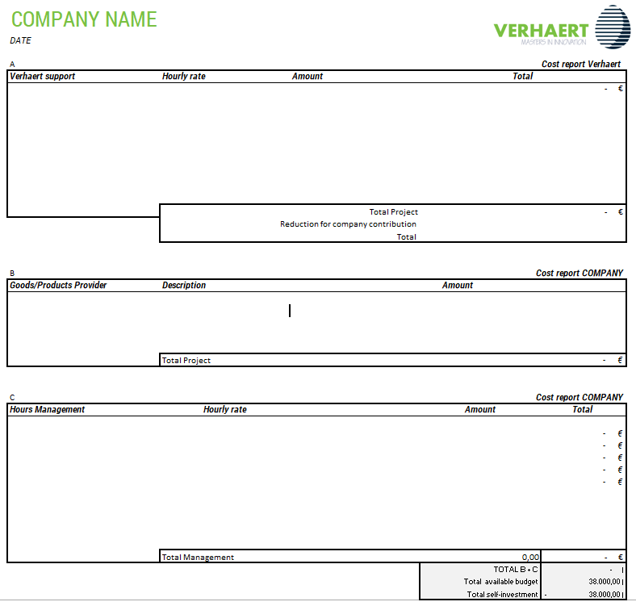

2.4 DELIVERABLES AND REPORTS

- Communication with Verhaert and ESA

The following documents shall be handed over enduring the Proof of Concept-venture.

Doc ID | Title | Milestone | Date
MoM | Minutes of the kick-off Meeting | Official start of the project. | [M1]
CALL (VPS) | Process reporting | Progress track | Biweekly [M1-M6]
MTR | Proof of Concept-report | Mid-term review | [M3]
MTR | Cost-report | Mid-term cost report | [M3]
MTR MoM | Presentation on the reports | MoM | [M3]
FR | Proof of Concept-Report | Final review | [M6]
FR | Cost report | Final review | [M6]
FR | Presentation for the Final Review with ESA | Final review | [M6]
FP | Financial report | Final MoM | [M6]

